January 7, 2025

ABEER AWAIS

DATA STRUCTURES

MISS IRSHA QURESHI

**Table of Contents**

**Lab 1: Introduction to DSA 3**

**Lab 2: Array 4**

**Lab 3: 2d Array 8**

**Lab 4: Vector 13**

**Lab 5: List 16**

**Lab 6: Stacks 19**

**Lab 7: Queues 24**

**Lab 8: Deque 27**

**Lab 9: Trees 30**

**Lab 10: Binary Search trees 35**

**Lab 11: Singly link list 38**

**Lab 12: Doubly link list 21**

**Lab 13: Circular link list 50**

**Lab 1: Introduction to DSA**

**What are data structures**

* A data structure is a way to store data.
* We structure data in different ways depending on what data we have, and what we want to do with it

**What are algorithms**

* An algorithm is a set of step-by-step instructions to solve a given problem or achieve a specific goal
* Algorithms are fundamental to computer programming as they provide step-by-step instructions for executing tasks

**Types of data structures**

* There are two types of data structures
  1. **Primitive Data Structures:** Basic data structures provided by programming languages to represent single values, such as integers, floating-point numbers, characters, and Booleans.
  2. **Abstract Data Structures**: Higher-level data structures that are built using primitive data types and provide more complex and specialized operations. They are further divided into two types
     + **Linear:** Which have fixed size like arrays, list, stack and queue
     + **Non-Linear:** Which do not have fixed size like trees and graphs

**Where are data structures used**

* Operating Systems
* Database Systems
* Web Applications

**Lab 2: Array**

* **Definition:** An array is a data structure that stores a fixed-size sequential collection of elements of the same type. In other words, it’s a collection of variables (called elements), all of the same type, stored under a single variable name
* **Syntax:** data-type variable name [size] = {elements}
* **Key Characteristics of an Array:**

1. Fixed Size

2. Same Type

3. Indexing

* **Example Programs**

1. **Find the sum and average of an array**

#include<iostream>

using namespace std;

int main() {

int n,sum=0,average;

cout << "Enter size: ";

cin >> n;

int arr[n];

cout << "Enter elements: ";

for (int i = 0; i < n; i++) {

cin >> arr[i];

}

for (int i = 0; i < n; i++) {

sum +=arr[i];

}

average = sum/n;

cout<<"Sum of array is: "<<sum<<endl;

cout<<"Average of array is: "<<average;

}

**Output**

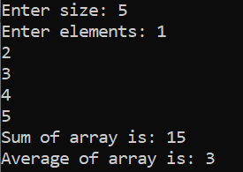

1. **Find the** **Maximum and Minimum of an array**

#include<iostream>

using namespace std;

int main() {

int mx = INT_MIN;

int mn = INT_MAX;

int n;

cout << "Enter size: ";

cin >> n;

int arr[n];

cout << "Enter elements: ";

for (int i = 0; i < n; i++) {

cin >> arr[i];

}

for (int i = 0; i < n; i++) {

mx = max(mx, arr[i]);

}

cout << "Maximum number is: " << mx << endl;

for (int i = 0; i < n; i++) {

mn = min(mn, arr[i]);

}

cout << "Minimum number is: " << mn;

return 0;

}

**Output**

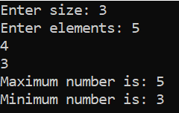

1. **Reverse an Array**

#include <iostream>

using namespace std;

int main() {

int n=8;

int originalArray[n]={1,2,3,4,5,6,7,8};

int reversedArray[n];

for (int i = 0; i < n; ++i) {

reversedArray[i] = originalArray[n - 1 - i];

}

cout << "Original Array: ";

for (int i = 0; i < n; ++i) {

cout << originalArray[i] << " ";

}

cout << endl;

cout << "Reversed Array: ";

for (int i = 0; i < n; ++i) {

cout << reversedArray[i] << " ";

}

cout << endl;

return 0;}

**Output**



1. **Count characters in an array**

#include <iostream>

using namespace std;

int main() {

char arr[10];

char check;

cout<<"Enter 10 characters: ";

for(int i = 0; i < 10; i++) {

cin >> arr[i];

}

cout<<"Enter character to count: ";

cin>>check;

int count = 0;

for(int i = 0; i < 10; i++) {

if(arr[i] == check) count++;

}

cout << "Occurrences of " << check << ": " << count << endl;

return 0;

}

**Output**

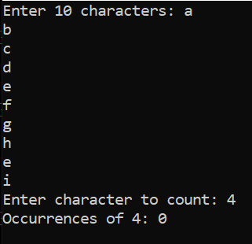

1. **Find duplicates in an array**

#include <iostream>

using namespace std;

int main() {

int arr[10], NewArr[10], Count = 0;

cout << "Enter 10 integers: ";

for (int i = 0; i < 10; i++) {

cin >> arr[i];

bool Duplicate = false;

// Check if arr[i] is already in NewArr

for (int j = 0; j < Count; j++) {

if (arr[i] == NewArr[j]) {

Duplicate = true;

break;

}

}

// If not a duplicate, add to NewArr

if (!Duplicate) {

NewArr[Count] = arr[i];

Count++;

}

}

cout << "Array without duplicates: ";

for (int i = 0; i < Count; i++) {

cout << NewArr[i] << " ";

}

cout << endl;

return 0;

}

**Output**

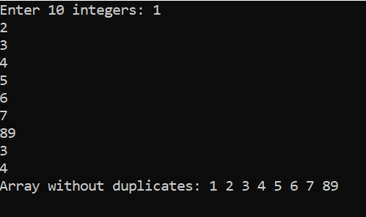

**Lab 3: 2d Array**

* **Definition:** A 2D array is a data structure that stores a fixed-size table-like collection of elements of the same type, organized in rows and columns. It is essentially an array of arrays, where each element is accessed using two indices: one for the row and one for the column.
* **Syntax:** data-type variable_name [rows][columns] = {{row1_elements}, {row2_elements}, ...};
* **Key Characteristics of a 2d Array:**

1. Fixed Size

2. Same Type

3. Indexing

* **Example Programs**

1. **Write Basic Implementation of 2d array**

#include<iostream>

using namespace std;

int main(){

int n,m;

cout<<"Enter rows: ";

cin>>n;

cout<<"Enter coloumns: ";

cin>>m;

int arr[n] [m];

cout<<"Enter elements: ";

for(int i=0;i<n;i++) {

for (int j=0;j<m;j++) {

cin>> arr[i][j];

}

}

cout<<"Matrix is: "<<endl;

for(int i=0;i<n;i++) {

for (int j=0; j<m;j++) {

cout<<arr[i][j]<<" ";

}

cout<<"\n";

}

}

**Output**

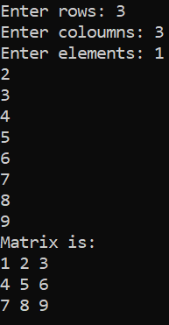

1. **Find the** **Maximum and Minimum of an array**

#include<iostream>

using namespace std;

int main(){

int n,m;

int mx=INT_MIN;

int mn=INT_MAX;

cout<<"Enter rows: ";

cin>>n;

cout<<"Enter coloumns: ";

cin>>m;

int arr[n] [m];

cout<<"Enter elements: ";

for(int i=0;i<n;i++) {

for (int j=0;j<m;j++) {

cin>> arr[i][j];}}

cout<<"Matrix is: "<<endl;

for(int i=0;i<n;i++) {

for (int j=0; j<m;j++) {

cout<<arr[i][j]<<" ";}

cout<<"\n";}

for(int i=0;i<n;i++) {

for (int j=0; j<m;j++) {

mx=max(mx,arr[i][j]);} }

cout << "Maximum number is: " << mx << endl;

for(int i=0;i<n;i++) {

for (int j=0; j<m;j++) {

mn=min(mn,arr[i][j]);} }

cout << "Minimum number is: " << mn << endl;}

**Output**

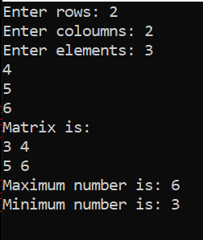

1. **Find the order of matrix in a 2d array**

#include<iostream>

using namespace std;

int main(){

int n,m,order;

cout<<"Enter rows: ";

cin>>n;

cout<<"Enter coloumns: ";

cin>>m;

int arr[n] [m];

cout<<"Enter elements: ";

for(int i=0;i<n;i++) {

for (int j=0;j<m;j++) {

cin>> arr[i][j];

}

}

cout<<"Matrix is: "<<endl;

for(int i=0;i<n;i++) {

for (int j=0; j<m;j++) {

cout<<arr[i][j]<<" ";

}

cout<<"\n";

}

order= n*m;

cout<<"Order of matrix is: "<<order;

}

**Output**

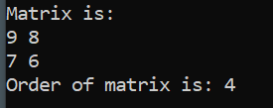

1. **Find the sum of matrices**

#include<iostream>

using namespace std;

int main() {

int n, m;

cout << "Enter rows: ";

cin >> n;

cout << "Enter columns: ";

cin >> m;

int a[n][m]; int b[n][m]; int c[n][m];

cout << "Enter elements of 1st matrix: ";

for(int i = 0; i < n; i++) {

for (int j = 0; j < m; j++) {

cin >> a[i][j];}}

cout << "1st Matrix is: " << endl;

for(int i = 0; i < n; i++) {

for (int j = 0; j < m; j++) {

cout << a[i][j] << " ";}

cout << "\n";}

cout << "Enter elements of 2nd matrix: ";

for(int i = 0; i < n; i++) {

for (int j = 0; j < m; j++) {

cin >> b[i][j];}}

cout << "2nd Matrix is: " << endl;

for(int i = 0; i < n; i++) {

for (int j = 0; j < m; j++) {

cout << b[i][j] << " ";}

cout << "\n";}

cout << "Total of Matrices is: " << endl;

for(int i = 0; i < n; i++) {

for (int j = 0; j < m; j++) {

c[i][j] = a[i][j] + b[i][j];

cout << c[i][j] << " ";}

cout << "\n";}

return 0;

}

**Output**

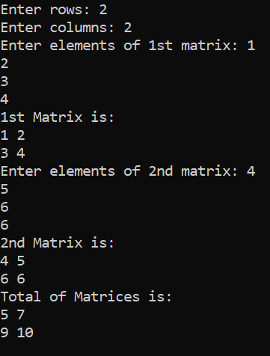

1. **Find Average in a 2d array**

#include <iostream>

using namespace std;

int main() {

int array[3][3] = {

{1, 2, 3},

{4, 5, 6},

{7, 8, 9}

};

int rows = 3, cols = 3;

int sum = 0;

int count = 0;

for (int i = 0; i < rows; i++) {

for (int j = 0; j < cols; j++) {

sum += array[i][j];

count++;

}

}

float average = (float)sum / count;

cout<<"The average of the 2D array elements is:"<<average;

return 0;

}

**Output**



**Lab 4: Vectors**

* **Definition:** A vector is a dynamic array provided by the Standard Template Library (STL) in C++. It stores a collection of elements of the same type in a contiguous memory block, and its size can grow or shrink dynamically as needed
* **Syntax:** vector<data-type> variable_name;
* **Key Characteristics of a Vector:**

1. **Dynamic Size**: Vectors can grow or shrink as needed.
2. **Ordered**: Elements are stored in a defined order.
3. **Indexing**: Elements can be accessed using zero-based indices.

* **Example Programs**

1. **Create a student vector list**

#include<iostream>

#include<vector>

using namespace std;

int main(){

vector <string>students={"Abeer","Seemal","Qandeel","Eman","Hamza"};

for(int i=0;i<4;i++){

cout<<"Student "<<i+1<<" : "<<students[i]<<endl;

}

}

**Output**

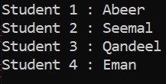

1. **Create a college vector list**

#include<iostream>

#include<vector>

using namespace std;

int main(){

vector <string>colleges={"PGC","Kips","Alley","TIPS"};

for(int i=0;i<4;i++){

cout<<"College "<<i+1<<" : "<<colleges[i]<<endl;

}

}

**Output**

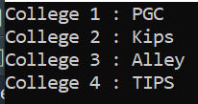

1. **Create a marks vector** **list**

#include<iostream>

#include<vector>

using namespace std;

int main(){

vector <int>marks={6,8,5,3,2};

for(int i=0;i<4;i++){

cout<<"Marks "<<i+1<<" : "<<marks[i]<<endl;

}

}

**Output**

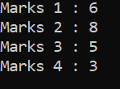

1. **Create a match scores vector list**

#include<iostream>

#include<vector>

using namespace std;

int main(){

vector <int>scores={8,8,7,3,2};

for(int i=0;i<4;i++){

cout<<"Score of match "<<i+1<<" : "<<scores[i]<<endl;

}

}

**Output**

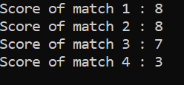

1. **Create a price vector list**

#include <iostream>

#include <vector>

using namespace std;

int main() {

vector<double> prices = {99.99, 149.49, 199.99, 249.99, 299.99};

for (int i = 0; i < 4; i++) {

cout << "Price " << i + 1 << " : " << prices[i] << endl;

}

return 0;

}

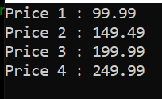

**Output**

**Lab 5: List**

* **Definition:** A list is a data structure that stores a dynamic collection of ordered elements, where each element can be of the same or different types. Lists allow easy insertion, deletion, and access of elements based on their position.
* **Syntax:** list<data-type> variable_name;
* **Key Characteristics of a List:**

1. **Dynamic Size**: List can grow or shrink as needed.
2. **Ordered**: Elements are stored in a defined order.
3. **Indexing**: Elements can be accessed using zero-based indices.

* **Examples**

1. **Write the basic implementation of a list**

#include <iostream>

#include <list>

using namespace std;

int main() {

list<int> numbers;

numbers.push_back(10);

numbers.push_front(20);

numbers.push_back(30);

cout << "List elements: ";

for (int num : numbers) {

cout << num << " ";

}

cout << std::endl;

numbers.pop_front();

cout << "After removing front element: ";

for (int num : numbers) {

cout << num << " ";

}

cout << std::endl;

return 0;

}

**Output**

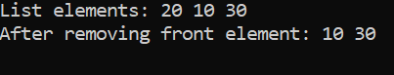

1. **Create a shopping cart list**

#include <iostream>

#include <list>

using namespace std;

int main() {

list<string> shopping;

string choice,item;

while(true) {

cout << "Enter your choice (add/remove/display/exit): ";

cin >> choice;

if(choice == "add") {

cout << "Enter item to add: ";

cin >> item;

shopping.push_back(item);

} else if(choice == "remove") {

string item;

cout << "Enter item to remove: ";

cin >> item;

shopping.remove(item);

} else if(choice == "display") {

cout << "Shopping list: ";

for(auto &item : shopping) cout << item << " ";

cout << endl;

} else if(choice == "exit") {

break;

**Output**

}

} 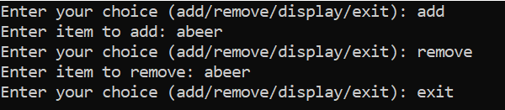

return 0;

}

1. **Create a student List**

#include <iostream>

#include <list>

#include <vector>

#include <algorithm>

using namespace std;

int main() {

list<string> student;

string choice, name;

while (true) {

cout << "Enter your choice (add/remove/display/sort/exit): ";

cin >> choice;

if (choice == "add") {

cout << "Enter name of student to add: ";

cin >> name;

student.push_back(name);

} else if (choice == "remove") {

cout << "Enter name of student to remove: ";

cin >> name;

student.remove(name);}

else if (choice == "display") {

cout << "Students list: ";

for (auto &name : student) cout << name << " ";

cout << endl;

} else if (choice == "sort") {

vector<string> temp(student.begin(), student.end());

sort(temp.begin(), temp.end());

cout << "Sorted Students list: ";

for (auto &name : temp) cout << name << " ";

cout << endl;

} else if (choice == "exit") {

break;

} else {

cout << "Invalid choice. Please try again." << endl;}}

return 0;

}

**Output**

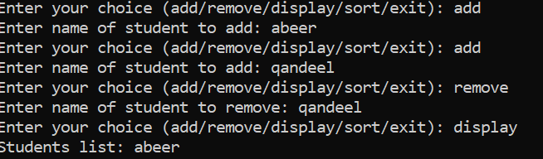

1. **Merge two lists**

#include <iostream>

#include <list>

#include <algorithm>

using namespace std;

int main() {

list<int> list1 = {40, 10, 30};

list<int> list2 = {25, 15, 35};

list1.sort();

list2.sort();

list1.merge(list2);

cout << "Merged and sorted list: ";

for (int num : list1) {

cout << num << " ";}

cout << std::endl;}

**Output**



1. **Create a grades List**

#include<iostream>

#include<list>

using namespace std;

int main(){

list <float>grades={'A','B','C','A','E'};

cout<<"Students grades are"<<endl;

grades.pop_front();

grades.pop_back();

for(char grades: grades){

cout<<grades<<endl;

}

}

**Output**

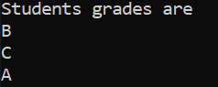

**Lab 6: Stack**

* **Definition:** A stack is a dta structure that stores a collection of elements following the Last In, First Out (LIFO) principle. Elements can only be added or removed from the top of the stack. Stacks allow efficient insertion and deletion operations but restrict access to elements based on their position in the stack.
* **Syntax:** stack<data-type> variable_name;
* **Key Characteristics of a stack:**

1. **LIFO (Last In, First Out)**: Elements follow the last-in, first-out principle, where the last element added is the first to be removed.
2. **Restricted Access**: Elements can only be added or removed from the top of the stack.
3. **No Indexing**: Elements are accessed based on their position in the stack, not via indexing

* **Example Programs**

1. **Write the basic Implementation of stack**

**Output**

#include<iostream>

#include<string> 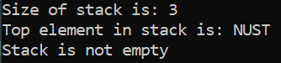

#include<stack>

using namespace std;

int main(){

stack<string>universities;

universities.push("TUF");

universities.push("FAST");

universities.push("NUST");

universities.push("LUMS");

universities.push("NTU");

universities.push("BNU");

universities.pop();

universities.pop();

universities.pop();

cout<<"Size of stack is: "<<universities.size()<<"\n";

cout<<"Top element in stack is: "<<universities.top();

if(universities.empty()==true){

cout<<"\nStack is empty";

}

else

cout<<"\nStack is not empty";}

1. **Find if the stack is palindrome**

**Output**

#include<iostream>

#include<stack>

using namespace std; 

int main(){

string word;

cout<<"Enter your word: ";

cin>>word;

stack<char> x;

for(char c : word) x.push(c);

string rev;

while(!x.empty()) {

rev += x.top();

x.pop();

}

if(word == rev)

cout <<"Your word is a palindrome."<<endl;

else

cout<<"Your word is not a palindrome."<<endl;

}

**3.Find the Postfix Evaluation**

#include <iostream>

#include <stack>

using namespace std;

int evaluatePostfix(string exp)

{

stack<int> st;

for (int i = 0; i < exp.size(); ++i) {

if (isdigit(exp[i]))

st.push(exp[i] - '0');

else {

int val1 = st.top();

st.pop();

int val2 = st.top();

st.pop();

switch (exp[i]) {

case '+':

st.push(val2 + val1);

break;

case '-':

st.push(val2 - val1);

break;

case '*':

st.push(val2 * val1);

break;

case '/':

st.push(val2 / val1);

break;

}

}

}

return st.top();

}

int main()

{

string exp = "231*+9-";

cout << "postfix evaluation: " << evaluatePostfix(exp);

return 0;

}

**Output**



1. **Create a undo text software**

#include <iostream>

#include <stack>

using namespace std;

int main() {

stack<string> commandStack;

string choice;

while (true) {

cout << "Enter your choice (add, undo, exit): ";

cin >> choice;

if (choice == "add") {

string addText;

cout << "Enter the text you want to add: ";

cin.ignore();

cin>>addText;

commandStack.push(addText);

cout << "Text added.\n";

} else if (choice == "undo") {

if (!commandStack.empty()) {

cout << "Undoing last text: " << commandStack.top() << endl;

commandStack.pop();

} else {

cout << "No text to undo.\n";

}

} else if (choice == "exit") {

break;

} else {

cout << "Invalid choice. Please enter 'add', 'undo', or 'exit'.\n";

}

}

}

**Output**

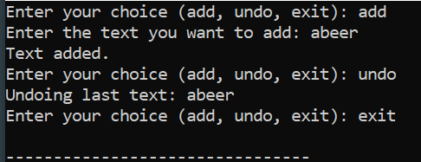

**Lab 7: Queue**

* **Definition:** A queue is a data structure that stores a collection of elements following the **First In, First Out (FIFO)** principle. Elements are added at the back enqueue) and removed from the front (dequeue). Queues allow efficient insertion and deletion operations while maintaining the order in which elements were added
* **Syntax:** queue<data-type> variable_name;
* **Key Characteristics of a Queue:**

1. **FIFO (First In, First Out)**: Elements follow the first-in, first-out principle, where the first element added is the first to be removed.
2. **Sequential Processing**: Ideal for scenarios requiring sequential order of processing.
3. **No Indexing**: Elements are accessed in a linear fashion, not via indexing

* **Example Programs**

1. **Write the basic Implementation of queue**

#include <iostream>

#include <queue>

using namespace std;

int main() {

queue<int> q;

q.push(5);

q.push(10);

q.push(15);

cout << "Front: " << q.front() << ", Back: " << q.back() << endl;

q.pop();

cout << "After pop, Front: " << q.front() << endl;

return 0;

}

**Output**

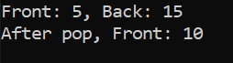

1. **Check the size and emptiness of queue**

#include <iostream>

#include <queue>

using namespace std;

int main() {

queue<int> q;

q.push(1); q.push(2); q.push(3);

cout << "Queue Size: " << q.size() << endl;

cout << "Is Empty: " << (q.empty() ? "Yes" : "No") << endl;

return 0;}

**Output**

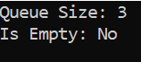

1. **How queue works with strings**

#include <iostream>

#include <queue>

using namespace std;

int main() {

queue<string> q;

q.push("Alice");

q.push("Bob");

cout << "Front: " << q.front() << ", Back: " << q.back() << endl;

q.pop();

cout << "After pop, Front: " << q.front() << endl;

return 0;

}

**Output**



1. **Iterating over queue**

#include <iostream>

#include <queue>

#include <stack>

using namespace std

int main() {

queue<int> q; stack<int> s;

for (int i = 1; i <= 5; ++i) q.push(i);

while (!q.empty()) { s.push(q.front()); q.pop(); }

while (!s.empty()) { cout << s.top() << " "; s.pop(); }

return 0;

}

**Output**



1. **Merging two queues**

#include <iostream>

#include <queue>

using namespace std;

int main() {

queue<int> q1, q2;

q1.push(1); q1.push(2);

q2.push(3); q2.push(4);

while (!q1.empty()) { cout << q1.front() << " "; q1.pop(); }

while (!q2.empty()) { cout << q2.front() << " "; q2.pop(); }

return 0;

}

**Output**



**Lab 8: Deque**

* **Definition:** A deque is a data structure that stores a collection of elements and allows insertion and deletion from both ends (front and back). Deques provide flexibility for accessing elements while maintaining an ordered sequence. They are ideal for scenarios requiring dynamic resizing and dual-end operations.
* **Syntax:** deque<data-type> variable_name;
* **Key Characteristics of a Queue:**

1. **Flexible Access**: Elements can be added or removed from both ends (front and back).
2. D**ynamic Size**: Deques can grow or shrink as needed.

* **Example Programs**

1. **Write basic implementation of deque**

**Output**

#include <iostream>



#include <deque>

using namespace std;

int main() {

deque<int> dq;

dq.push_back(5);

dq.push_front(10);

cout << "Front: " << dq.front() << ", Back: " << dq.back() << endl;

dq.pop_front();

cout << "After pop_front, Front: " << dq.front() << endl;

return 0;

}

1. **Size and Empty Check of deque**

**Output**

#include <iostream>

#include <deque> 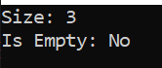

using namespace std;

int main() {

deque<int> dq = {1, 2, 3};

cout << "Size: " << dq.size() << endl;

cout << "Is Empty: " << (dq.empty() ? "Yes" : "No") << endl;

return 0;

}

1. **Deque used as Stack**

**Output**

#include <iostream>

#include <deque> 

using namespace std;

int main() {

deque<int> dq;

dq.push_back(5);

dq.push_back(10);

dq.pop_back();

cout << "Top of stack: " << dq.back() << endl;

return 0;

}

1. **Iterating our deque**

**Output**

#include <iostream>

#include <deque> 

using namespace std;

int main() {

deque<int> dq = {1, 2, 3, 4};

for (int x : dq) cout << x << " ";

return 0;

}

1. **Reversing our deque**

**Output**

#include <iostream>

#include <deque> 

#include <algorithm>

using namespace std;

int main() {

deque<int> dq = {1, 2, 3, 4};

reverse(dq.begin(), dq.end());

for (int x : dq) cout << x << " ";

return 0;

}

**Lab 9: Trees**

* **Definition:** A tree is a hierarchical data structure that organizes elements in a parent-child relationship. It starts with a single root node and branches into sub-nodes (children), forming levels. Each node can have zero or more children, and there is no limit to the depth of the hierarchy. Trees are widely used for efficient searching, sorting, and hierarchical data representation
* **Key Characteristics of a Tree:**

1. **Hierarchical Structure**: Organized in levels, with a root node and child nodes forming a hierarchy.
2. **Parent-Child Relationship**: Each node (except the root) has one parent and may have multiple children.
3. **Recursive Representation**: Trees are naturally represented and traversed using recursion (e.g., in-order, pre-order, post-order).

**Examples**

1. **Implement simple binary tree**

**Output**

#include <iostream>

using namespace std;

struct Node { 

int data;

Node *left, *right;

Node(int val) : data(val), left(nullptr), right(nullptr) {}

};

int main() {

Node* root = new Node(1);

root->left = new Node(2);

root->right = new Node(3);

cout << "Root: " << root->data << ", Left: " << root->left->data << ", Right: " << root->right->data << endl;

return 0;

}

1. **Find Preorder Traversal**

**Output**

#include <iostream>

using namespace std; 

struct Node {

int data;

Node *left, *right;

Node(int val) : data(val), left(nullptr), right(nullptr) {}

};

void preorder(Node* root) {

if (!root) return;

cout << root->data << " ";

preorder(root->left);

preorder(root->right);

}

int main() {

Node* root = new Node(1);

root->left = new Node(2);

root->right = new Node(3);

preorder(root);

return 0;

}

1. **Find In-order Traversal**

**Output**

#include <iostream>

using namespace std; 

struct Node {

int data;

Node *left, *right;

Node(int val) : data(val), left(nullptr), right(nullptr) {}

};

void inorder(Node* root) {

if (!root) return;

inorder(root->left);

cout << root->data << " ";

inorder(root->right);

}

int main() {

Node* root = new Node(1);

root->left = new Node(2);

root->right = new Node(3);

inorder(root);

return 0;

}

1. **Find Post-order Traversal**

**Output**

#include <iostream>

using namespace std;

struct Node { 

int data;

Node *left, *right;

Node(int val) : data(val), left(nullptr), right(nullptr) {}

};

void postorder(Node* root) {

if (!root) return;

postorder(root->left);

postorder(root->right);

cout << root->data << " ";

}

int main() {

Node* root = new Node(1);

root->left = new Node(2);

root->right = new Node(3);

postorder(root);

return 0;

}

1. **Find Level Order Traversal**

**Output**

#include <iostream>

#include <queue> 

using namespace std;

struct Node {

int data;

Node *left, *right;

Node(int val) : data(val), left(nullptr), right(nullptr) {}

};

void levelOrder(Node* root) {

if (!root) return;

queue<Node*> q;

q.push(root);

while (!q.empty()) {

Node* curr = q.front();

q.pop();

cout << curr->data << " ";

if (curr->left) q.push(curr->left);

if (curr->right) q.push(curr->right);

}

}

int main() {

Node* root = new Node(1);

root->left = new Node(2);

root->right = new Node(3);

levelOrder(root);

return 0;

}

**Lab 10: Binary Search Trees**

* **Definition:** A Binary Search Tree (BST) is a type of binary tree in which each node follows a specific ordering property:
  1. **Left Subtree**: Contains nodes with keys less than the parent node's key.
  2. **Right Subtree**: Contains nodes with keys greater than the parent node's key. This property makes BSTs highly efficient for searching, insertion, and deletion operations.
* **Key Characteristics of a Tree:**
  1. **Ordered Structure**: Nodes are arranged in a way that enables efficient operations.
  2. **Recursive Representation**: BST operations like traversal and manipulation are naturally implemented using recursion.
  3. **No Duplicates**: In a standard BST, duplicate elements are not allowed.
  4. **Traversals**: Common traversal methods include in-order, pre-order, and post-order, where in-order traversal yields a sorted sequence of elements.

**Examples**

1. **Insertion in BST**

**Output**

struct Node {

int data; 

Node* left;

Node* right;

Node(int value) :

data(value), left(nullptr), right(nullptr) {}

};

Node* insert(Node* root, int value) {

if (root == nullptr) return new Node(value);

if (value < root->data)

root->left = insert(root->left, value);

else

root->right = insert(root->right, value);

return root;}

1. **Deletion in BST**

**Output**

Node* findMin(Node* root) {

while (root->left != nullptr) root = root->left;

return root; 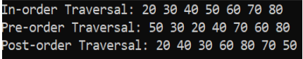

}

Node* deleteNode(Node* root, int value) {

if (root == nullptr) return root;

if (value < root->data)

root->left = deleteNode(root->left, value);

else if (value > root->data)

root->right = deleteNode(root->right, value);

else {

if (root->left == nullptr) return root->right;

if (root->right == nullptr) return root->left;

Node* temp = findMin(root->right);

root->data = temp->data;

root->right = deleteNode(root->right, temp->data);

}

return root;

}

1. **Searching in BST**

**Output**

bool search(Node* root, int value) {

if (root == nullptr) return false;

if (root->data == value) return true; 

if (value < root->data)

return search(root->left, value);

return search(root->right, value);}

1. **Traversing in BST(in-order, pre-order, post-order)**

**Output**

void inOrder(Node* root) {

if (root == nullptr) return;

inOrder(root->left); 

std::cout << root->data << " ";

inOrder(root->right);

}

void preOrder(Node* root) {

if (root == nullptr) return;

std::cout << root->data << " ";

preOrder(root->left);

preOrder(root->right);

}

void postOrder(Node* root) {

if (root == nullptr) return;

postOrder(root->left);

postOrder(root->right);

std::cout << root->data << " ";

}

1. **Minimum and Maximum**

int findMinValue(Node* root) {

**Output**

while (root->left != nullptr) root = root->left;

return root->data; 

}

int findMaxValue(Node* root) {

while (root->right != nullptr) root = root->right;

return root->data;

**LAB 11**

**Definition:** A Linked List is a linear data structure where elements, called nodes, are connected using pointers. Each node contains two parts.

* Singly link list: A singly link list is the link where each node has a single pointer to the next node. It Traverses is one-directional and the last node’s pointer is nullptr.

Q1: INSERTION AT ANY POINT

#include<iostream>

using namespace std;

class node{

    public:

    int data;

    node *link;

    node *head;

    node *tail;

    node *current;

    node (){

        head = nullptr;

        tail = nullptr;

    }

    void create(int data){

        if(head == nullptr){

        node *n = new node();

        n->data = data;

        n->link = nullptr;

        head = tail = n;

        }

        else{

        node *n = new node();

        n->data = data;

        n->link = nullptr;

        tail->link=n;

        tail = n;

        }

    }

    void insertAtBegin(int data) {

        node *n = new node();

        n->data = data;

        n->link = head;

        head = n;

    }

    void display(){

        current = head;

        while(current!=nullptr){

            cout<<current->data<<" ";

            current = current->link;

        }

    }

};

int main(){

    node abeer;

    abeer.create(5);

    abeer.insertAtBegin(3);

    abeer.display();

}

**output**



**Q2: deletion at start**

#include<iostream>

using namespace std;

class node{

    public:

    int data;

    node *link;

    node *head;

    node *tail;

    node *current;

    node (){

        head = nullptr;

        tail = nullptr;

    }

    void create(int data){

        if(head == nullptr){

        node *n = new node();

        n->data = data;

        n->link = nullptr;

        head = tail = n;

        }

        else{

        node *n = new node();

        n->data = data;

        n->link = nullptr;

        tail->link=n;

        tail = n;

        }

    }

    void deleteAtBegin() {

        if (head == nullptr) {

            cout << "List is empty." << endl;

            return;

        }

        node *temp = head;

        head = head->link;

        delete temp;

        if (head == nullptr) {  // If the list is now empty, set tail to nullptr

            tail = nullptr;

        }

    }

    void display(){

        current = head;

        while(current!=nullptr){

            cout<<current->data<<" ";

            current = current->link;

        }

    }

};

int main(){

    node hamza;

    hamza.create(5);

    hamza.display();

}

**output**

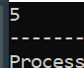

**Q3: insert at any point**

#include<iostream>

using namespace std;

class node{

    public:

    int data;

    node *link;

    node *head;

    node *tail;

    node *current;

    node (){

        head = nullptr;

        tail = nullptr;

    }

    void create(int data){

        if(head == nullptr){

        node *n = new node();

        n->data = data;

        n->link = nullptr;

        head = tail = n;

        }

        else{

        node *n = new node();

        n->data = data;

        n->link = nullptr;

        tail->link=n;

        tail = n;

        }

    }

    void insertAtPosition(int data, int position) {

        node *n = new node();

        n->data = data;

        if (position == 0) { // Insert at the beginning

            n->link = head;

            head = n;

            if (tail == nullptr) {

                tail = n;

            }

        } else {

            current = head;

            for (int i = 0; i < position - 1 && current != nullptr; ++i) {

                current = current->link;

            }

            if (current != nullptr) {

                n->link = current->link;

                current->link = n;

                if (n->link == nullptr) {

                    tail = n;

                }

            } else {

                cout << "Position out of bounds" << endl;

            }

        }

    }

    void display(){

        current = head;

        while(current!=nullptr){

            cout<<current->data<<" ";

            current = current->link;

        }

    }

};

int main(){

    node abeer;

    abeer.create(5);

    abeer.create(5);

    abeer.create(5);

   abeer.insertAtPosition(2,2);

   abeer.display();

}

**Output**



**Q4: delete at any point**

#include<iostream>

using namespace std;

class node {

    public:

    int data;

    node *link;

    node *head;

    node *tail;

    node *current;

    node() {

        head = nullptr;

        tail = nullptr;

    }

    void create(int data) {

        node *n = new node();

        n->data = data;

        n->link = nullptr;

        if (head == nullptr) {

            head = tail = n;

        } else {

            tail->link = n;

            tail = n;

        }

    }

    void deleteAtBegin() {

        if (head == nullptr) {

            cout << "List is empty." << endl;

            return;

        }

        node *temp = head;

        head = head->link;

        if (head == nullptr) { // List had only one node, so update tail

            tail = nullptr;

        }

        delete temp;

    }

    void deleteAtPosition(int position) {

        if (head == nullptr) {

            cout << "List is empty." << endl;

            return;

        }

        if (position == 0) { // Special case for deleting the head

            deleteAtBegin();

            return;

        }

        current = head;

        for (int i = 0; i < position - 1 && current->link != nullptr; ++i) {

            current = current->link;

        }

        if (current->link == nullptr) {

            cout << "Position out of bounds." << endl;

        } else {

            node *temp = current->link;

            current->link = temp->link;

            if (temp->link == nullptr) { // Update tail if we're deleting the last node

                tail = current;

            }

            delete temp;

        }

    }

    void display() {

        current = head;

        while (current != nullptr) {

            cout << current->data << " ";

            current = current->link;

        }

        cout << endl;

    }

};

int main() {

    node abeer;

   abeer.create(5);

   abeer.create(10);

   abeer.create(15);

    cout << "Original list: ";

   abeer.display();

   abeer.deleteAtPosition(2);

    cout << "After deleting at position 2: ";

   abeer.display();

   abeer.deleteAtPosition(0);

    cout << "After deleting at position 0: ";

   abeer.display();

    return 0;

}

**Output**

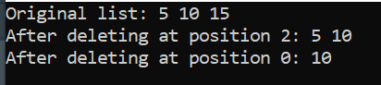

**Q5: insert at last**

#include<iostream>

using namespace std;

class node{

    public:

    int data;

    node *link;

    node *head;

    node *tail;

    node *current;

    node (){

        head = nullptr;

        tail = nullptr;

    }

    void create(int data){

        if(head == nullptr){

        node *n = new node();

        n->data = data;

        n->link = nullptr;

        head = tail = n;

        }

        else{

        node *n = new node();

        n->data = data;

        n->link = nullptr;

        tail->link=n;

        tail = n;

        }

    }

    void insertAtEnd(int data) {

        node *n = new node();

        n->data = data;

        n->link = nullptr;

        if (head == nullptr) {

            head = tail = n;

        } else {

            tail->link = n;

            tail = n;

        }

    }

    void display(){

        current = head;

        while(current!=nullptr){

            cout<<current->data<<" ";

            current = current->link;

        }

    }

};

int main(){

    node abeer;

   abeer.create(5);

   abeer.insertAtEnd(6);

 abeer.display();

}

**Output**



**Lab 12: Doubly Link List**

* **Characteristics**
  1. Each node has pointers to both the previous and next nodes.
  2. Traversal is bidirectional.
  3. The head’s prev pointer and the last node’s next pointer are nullptr.
* **Example Programs**

1. **Node Structure**

**Output**

struct DoublyNode {

int data;

DoublyNode* prev;

DoublyNode* next;

DoublyNode(int val) : data(val), prev(nullptr), next(nullptr) {}

};

1. **Insertion at end**

**Output**

void insertEnd(DoublyNode*& head, int val) {

DoublyNode* newNode = new DoublyNode(val);

if (head == nullptr) {

head = newNode;

return;

}

DoublyNode* temp = head;

while (temp->next != nullptr) {

temp = temp->next;

}

temp->next = newNode;

newNode->prev = temp;}

1. **Deletion at value**

**Output**

void deleteNode(DoublyNode*& head, int val) {

if (head == nullptr) return;

if (head->data == val) {

DoublyNode* temp = head;

head = head->next;

if (head != nullptr) head->prev = nullptr;

delete temp;

return;

}

DoublyNode* temp = head;

while (temp != nullptr && temp->data != val) {

temp = temp->next;

}

if (temp == nullptr) return;

if (temp->next != nullptr) temp->next->prev = temp->prev;

if (temp->prev != nullptr) temp->prev->next = temp->next;

delete temp;

}

1. **Display the list**

**Output**

void display(DoublyNode* head) {

DoublyNode* temp = head;

while (temp != nullptr) {

cout << temp->data << " <-> ";

temp = temp->next;

}

cout << "nullptr" << endl;}

1. **Insert at postion**

**Output**

void insertatposition(int position,int data){

node *n = new node();

n->data=data;

if(position==1){

n->next=head;

if(head!=NULL){

head->prev=n;}

head = n;

if(tail==NULL){

tail=n;}}

else{

current = head;

int count = 1;

while(current!=nullptr && count<position-1){

current = current->next;

count++;}

if(current==NULL){

cout<<"position out of bounds";

delete n;

return;}

n->next=current->next;

n->prev=current;

if (current->next != nullptr) {

current->next->prev = n;} else { // If inserting at the tail

tail = n;}

current->next = n;}}

**Lab 13: Circular Link List**

**Characteristics**

* The last node points to the first node.
* Can be singly or doubly linked.
* Enables circular traversal.
* Example Programs

1. **Node Structure**

**Output**

struct CNode {

int data; 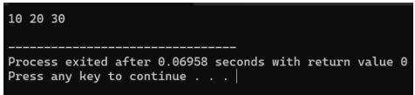

CNode* next;

CNode(int val) : data(val), next(nullptr) {}

};

1. **Insertion at end**

**Output**

void insertEnd(CNode*& head, int val) {

CNode* newNode = new CNode(val); 

if (head == nullptr) {

head = newNode;

newNode->next = head;

return;

}

CNode* temp = head;

while (temp->next != head) {

temp = temp->next;

}

temp->next = newNode;

newNode->next = head;

}

**Output**

1. **Deletion at value**

void deleteNode(CNode*& head, int val) { 

if (head == nullptr) return;

if (head->data == val && head->next == head) {

delete head;

head = nullptr;

return;

}

CNode* temp = head;

CNode* prev = nullptr;

do {

if (temp->data == val) break;

prev = temp;

temp = temp->next;

} while (temp != head);

if (temp == head && temp->data != val) return;

if (temp == head) {

prev = head;

while (prev->next != head) prev = prev->next;

head = head->next;

prev->next = head;

} else {

prev->next = temp->next;

}

delete temp;

} DoublyNode* temp = head;

while (temp != nullptr && temp->data != val) {

temp = temp->next;

}

if (temp == nullptr) return;

if (temp->next != nullptr) temp->next->prev = temp->prev;

if (temp->prev != nullptr) temp->prev->next = temp->next;

delete temp;

}

**Output**

1. **Display the list**

void display(CNode* head) {

if (head == nullptr) return;

CNode* temp = head; 

do {

cout << temp->data << " -> ";

temp = temp->next;

} while (temp != head);

cout << "(head)" << endl;

}

1. **Insert at position**

**Output**

void insertAtPosition(int data, int position) {

node *n = new node(); 

n->data = data;

if (position == 0) { // Insert at the beginning

n->link = head;

head = n;

if (tail == nullptr) {

tail = n;

}

} else {

current = head;

for (int i = 0; i < position - 1 && current != nullptr; ++i) {

current = current->link;

}

if (current != nullptr) {

n->link = current->link;

current->link = n;

if (n->link == nullptr) {

tail = n;

}

} else {

cout << "Position out of bounds" << endl;